**Getting Started**

1. Go to <https://tulane.scishield.com/>
2. Log in with your Tulane credentials.
3. A screenshot of a computer

   Description automatically generatedYou will be taken to the SciShield home page. You can access your **Lab Group page** in the left pane by clicking **View Lab Profile**.

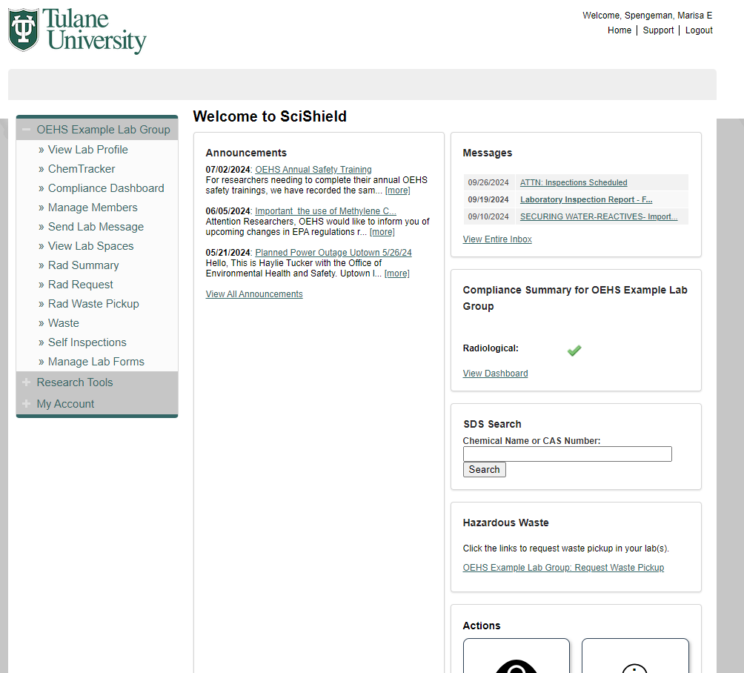

**3**

**Lab Group Page**

**How to add spaces**

Please contact **OEHS** to add spaces to your lab group. This function is not available to lab groups and can only be completed by **OEHS**.

**How to create a new group**

Please contact **OEHS** for assistance with creating your lab group. This function is not available to researchers and can only be completed by **OEHS**.

**How to Add New Members to a Lab**

1. From your **Lab Group** page, click the **Members** tab.
2. In the **Name** field, type the name of your lab member. Select the correct name from the drop-down list.

* If the name isn’t in the drop-down, they likely don’t have a Tulane email.

1. Select a **Designation** from the drop-down to assign the member’s title within your group. This is dependent on what the lab group feels appropriate and will have no effect on functionality within Scishield.
2. Under **Optional Access in SciShield**, check the boxes for the tasks the member will have access to.

* There is a question mark next to each option; hover over it for more detailed information.

1. In the **Job Activities** section, check the boxes for the hazards the member may be exposed to in each hazard category.
2. Click the **Lookup/Add** button to add the member.
3. Once you've verified your lab members are correct, click **Confirm** **List** to finalize the list.

**How to choose a lab member’s role in “Optional Access in SciShield” section**

1. Selecting checkboxes under the **Optional Access in SciShield** section will adjust a lab member's functional abilities within your lab group.
2. Use the following guidelines to determine which **Optional Access in SciShield** checkboxes should be selected for different lab members in the **Members** tab of your lab group's page:

|  |  |
| --- | --- |
| **Lab managers or equivalent:** should have **all** access enabled.  **PIs:** will always have **all** optional access enabled |  |
| **Lab Members who may occasionally assist with SciShield** (e.g., graduate students):  Generally, do **NOT** check:  **Edit Basic Group Information**  **Group Compliance Liaison**  The rest of the options can be selected as needed. |  |
| **Lab members NOT responsible for updating information in SciShield** (e.g., rotating students, undergrads) |  |

**How to remove a lab member**

1. From your **Lab Group** page, click the **Members** tab.
2. Locate the lab member you wish to remove and click **Remove** in their row.
3. Click **Confirm**.

**How to give lab manager access to add new lab members**

1. From your **Lab Group** page, click the **Members** tab.
2. Find the lab manager’s name and click **Edit** in their row.
3. In the **Optional Access in SciShield** section, check the boxes for **Edit Basic Group Information** and **Group Compliance Liaison**.
4. Click **Save**.

**How to make chemicals available for sharing**

1. From your **Lab Group** page, click the **ChemTracker** tab or click **ChemTacker** from the left side menu.
2. Search for the chemical either by **chemical name** or **CAS number**.
3. For the chemical of interest, click **Edit**.
4. Using the **Container Status** dropdown menu, select **Surplus**.
5. Click **Update**.

**How to add chemicals to the inventory**

1. From your **Lab Group** page, click the **ChemTracker** tab.
2. Click **Add Inventory** sub-tab.
3. You can search for the chemical by **Name, CAS Number, or Product Name/Number**. Type in the chemical to be added and select the matching result.

* If the chemical is not found in the dropdown menu, contact **OEHS**.

1. In the **location or space field**, select where the chemical will be stored from the dropdown menu.

* If the desired space is not available in the dropdown menu, please contact **OEHS** to have a new space added.

1. Enter the **Amount** and **Units** for the chemical being added.

* **Container Status** will be set to Normal unless manually changed. There is a question mark next to the dropdown option; hover over it for more detailed information.

1. If barcodes are being utilized by the lab, the barcode would be scanned into the **Unique Container ID** field. If not, then this field can be left blank.
2. More information on the chemical and the location of storage can be optionally added to the **Addition Details** section.

* Expiration dates of reactive chemicals and peroxide formers need to be added to this section.

1. If the chemical is a controlled substance, check the **Controlled Substance** box.
2. Click **Create** or click **Create and Add Another** to add more than one chemical to the inventory.

**How to upload entire chemical inventory**

Entire chemical inventories cannot be added at once to the ChemTracker inventory.

**What chemicals should be included in chemical inventory**

All chemicals with hazard associations (flammable, corrosive, toxic, reactive, etc.) must be added to the ChemTracker inventory. This includes:

* Unmixed hazardous chemicals (liquids, powders, compressed gases) with a single CAS number.
* Common commercial pre-mixtures of chemicals.

DO NOT include:

* Non-hazardous materials
* Commercial products (e.g., paint, cleaning products)
* Biological samples
* Consumables (e.g., media or buffers)

**How to reconcile chemical inventory**

1. From your **Lab Group** page, click the **ChemTracker** tab or click **ChemTacker** from the left side menu.
2. Click **Reconciliation** below the **ChemTacker** tab.
3. At the bottom right of the page, click **Start a New Reconciliation**.
4. Select the **Space** of interest and optionally any more specific location information.
5. If containers were added into the chemical inventory by scanning barcodes, select the **Enter Container IDs** option. If not, then select the **Use Checklist** option.
6. Click **Submit**.
7. During **Section 2: Check Inventory**, check the boxes only for chemicals that you have confirmed to be in your lab.
8. Click **Next**.
9. During **Section 3: Remove Containers Not Found**, check the boxes of any chemicals that need to be removed from the inventory.
10. Click **Next**.
11. If you wish to review the inventory before finalizing, you can optionally click the **Download Reconciliation Data** option. If not, then you can complete the reconciliation by clicking **Finalize Reconciliation**. A summary will then be generated.

**How to search for available chemicals in your inventory**

1. From your **Lab Group** page, click the **ChemTracker** tab or click **ChemTacker** from the left side menu.
2. Type either chemical name, CAS number, or chemical synonym into the appropriate search bar.

**How to add a Safety Data Sheet (SDS) to chemical inventory**

1. From your **Lab Group** page, click the **ChemTracker** tab or click **ChemTacker** from the left side menu.
2. Search for the chemical by either **chemical name** or **CAS number**.
3. In the search results, find the **SDS Attachment** column and click **Add SDS** next to the chemical.
4. Select the appropriate SDS from the provided database options.
5. If the correct chemical or source is not listed, manually add the SDS by clicking **Upload SDS** or **Assign SDS as URL/Link**.
6. Click **Attach SDS** to complete the process.

**How to look up an uploaded SDS**

From ChemTracker:

1. From your **Lab Group** page, click the **ChemTracker** tab or click **ChemTacker** from the left side menu.
2. Search for the chemical either by **chemical name** or **CAS number**.
3. Under the **View SDS** column in the search results, click **View** for the chemical of interest.

From SciShield homepage:

1. On the **SciShield Homepage**, find the **SDS Search** on the right.
2. Enter the **Chemical Name** **or CAS Number** in the search bar.
3. Click **Search**.
4. In the **Search Results**, locate the chemical from the appropriate manufacturer and click **Download PDF**.

**How to upload an SOPs**

1. From your **Lab Group** page, click the **Documents** sub-tab.
2. At the bottom right of the page click **Attach a New Document**.
3. In the **Categories** section select the **Standard Operating Procedure** for the **File type** and choose the appropriate classification.
4. Choose the file to upload for your lab’s SOP.
5. (Optional) Add a description of the SOP.
6. Click **Submit**.

**How to create and print a lab door sign**

1. From your **Lab Group** page, go to the **Spaces** sub-tab.
2. Click the **Space Name** for the room you wish to create a door sign for.
3. Select the **Door Sign** sub-tab.
4. At the bottom of the page, click **Build Door Sign**.
5. In the **Layout** section, select the campus where the lab space is located.
6. In the **General Information** section, enter the full names and cell phone numbers for three emergency contacts. (Optional) Add a description of the space.

* **DO NOT** list office numbers in the primary phone section. The numbers provided should be those where a person can be reached outside of business hours.

1. In the **Header** section, choose the preferred header from the dropdown menu.
2. In the **Regulatory** section, select appropriate regulatory classifications and any special considerations from the dropdown menu.
3. In the **Area Hazards** section, indicate all hazards for the space by selecting the relevant boxes.
4. In the **Personal Protective Equipment/Precautions** section, indicate required PPE and precautions by checking the appropriate boxes.
5. (Optional) Add entrance instructions can be added to the **Entrance Procedures/Facility Instructions** section.
6. Click **Submit**.
7. To print the door sign click **Print Door Sign** at the bottom of the summary page.

* To reprint an existing door sign, follow steps 1-3 and click **Reprint** at the top of the page.

**How to review and update lab hazards for a lab group and door sign**

To update the entire lab group hazards:

1. From your **Lab Group** page, click the **Edit** tab.
2. Click the **Hazards** sub-tab.
3. Check the boxes of all hazards that apply to all spaces within the lab group.
4. Click **Submit**.

* From this page you can also review and update job activities that may have changed for lab members. Check the boxes for the job activities performed by respective lab personnel, then clicking **Submit**. If no changes are needed, you can exit the page.

To update the hazards for a space’s door sign:

1. From your **Lab Group** page, click the **Spaces** sub-tab.
2. Click the **Space Name** for the room you wish to update the hazards for.
3. Click the **Door Sign** sub-tab.
4. At the bottom of the page, click **Edit Door Sign**.
5. To auto populate the hazards previously identified for the entire lab group, in the **Known Lab Hazards** section click **Populate**.
6. Hazards specific to the space can be manually chosen in the **Space Hazards** section by clicking the appropriate boxes.

* There is a question mark next to each option; hover over it for more detailed information.

1. Click **Submit**.
2. The updated door sign can be printed by clicking **Reprint** at the top of the page.

**How to navigate follow-ups and resolve findings for an annual lab inspection**

1. After an annual lab inspection, you will be emailed the lab inspection report. Click the link in the email to confirm receipt of the report. You can also access the lab inspection report from your **Lab Group** page:

* From your Lab Group page, click the sub-tab **Lab Inspections**.
* For the lab inspection that you would like to follow up with, click **View** and you will be taken to the inspection report.

1. In the **Correspondence** section, select the correct option in the **Responses**.
   * Click **All Audit Findings Have Been Resolved** if all findings were corrected.
   * Click **Some Audit Findings Have Been Resolved** is only some findings were corrected.
   * Click **Corrective Actions Are in Progress But Not Yet Completed** if corrective actions are being taken but not yet completed.
   * Click **Have the Auditor Contact Me** if you need guidance or assistance with corrective actions.
2. In the **Resolved Findings** dropdown menu, select only the findings that you have resolved.
   * If you selected **Corrective Actions Are in Progress But Not Yet Completed** previously, do not click anything for **Resolved Findings**.
3. In **Additional Comments**, describe how the findings have been resolved.
   * If you selected **Corrective Actions Are in Progress But Not Yet Completed** previously, detail what steps are being taken to work towards correcting the findings.
4. In **Attach Documents**, click **Choose File** to attach photos of the resolved findings.
5. Click **Submit**.
   * OEHS will review updates on inspection reports and may contact you for more information that may be missing before finalizing the report. Once all findings are fully resolved and documented, the inspector will finalize the inspection.

**How to report safety concerns**

1. From the **SciShield Homepage**, locate the **Actions** section in the bottom right corner and click **Safety Concern** box.
2. From the **Type of observation** dropdown menu, select a description of your concern or observation.

* Hover over the question mark for more detailed information.

1. (Optional) To add photos of the safety observation, click **Choose Files** in the **Upload photos** section.
2. In the **Describe** section, type a description of the safety observation.

* Hover over the question mark for more detailed information.

1. In the **Location of Observation** section, use the **Building** and **Space/Room** dropdown menus to select the location of the incident or concern. You can provide additional details in the **Location Specifics** textbox.
2. Use the **Type of hazard** dropdown menu to select the type of safety concern observed.
3. If you wish to report your concern anonymously, click the **Anonymous Submission** box.
4. Click **Submit**.